Result Analysis

🡪If no errors, the control is taken to a streamlit local host environment and lets the user to input the pdf file from his/her local folders.

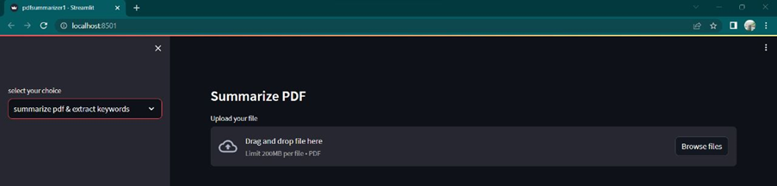

🡪The selected file is loaded into the local host webpage.

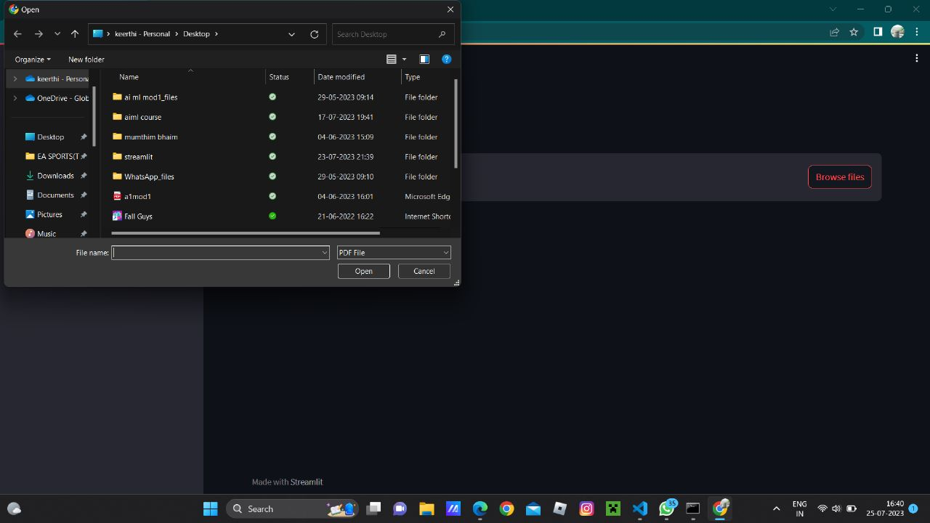

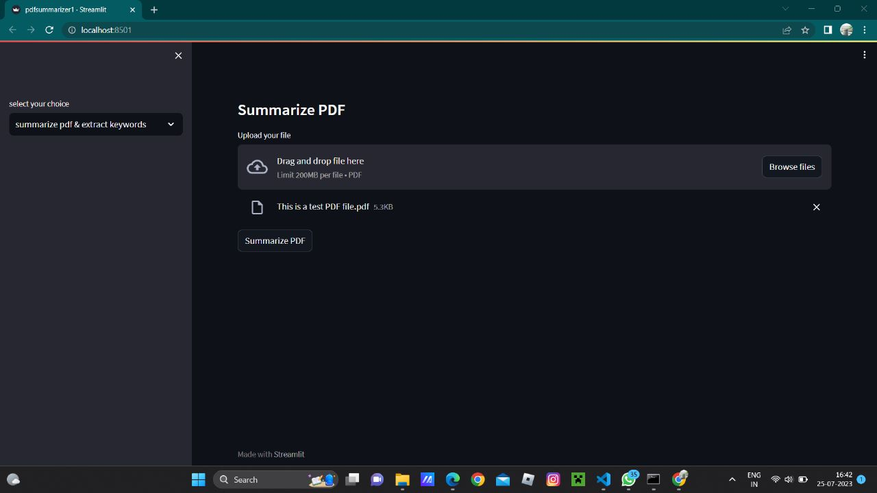

🡪The summarized text and its respective keywords are extracted and given as the output on the webpage.

